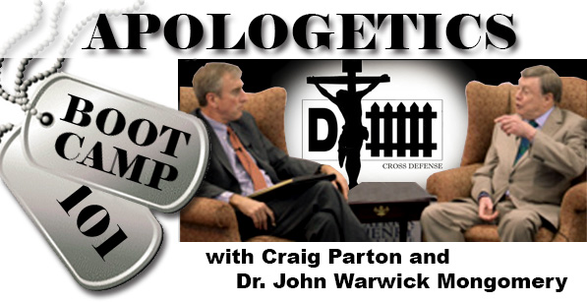
DOWNLOADABLE
BIBLE STUDY
FOR THE BROADCAST OF
NOVEMBER 3, 2014

- The particular Apologetic Boot Camp 101 program begins with a discussion about Jesus being a moral teacher. One must ask this question about Scripture: does the Bible make this as the main point, that God just wants us to do good, moral works? This is the law, i.e. what God demands humans do and not do to please Him. Early on in the Bible this becomes all humans problem, not their goal. Check this out in these references: Leviticus 19:2; James 2:10; Galatians 3:10-14 and list what they teach:

- Jesus thus fulfills the Law that we sinful humans can never satisfy (Hebrews 11:6 ). Not only this which is called “active obedience,” (Galatians 4:4-5) but additionally, Jesus’ passive obedience: his suffering and dying in our place to keep the Law. What do these passages tell us about this? Colossians 1:22 and Hebrews 2:14-----

- Dr. Montgomery speaks on this program about the reliability of the Bible. What do the following passages from the Bible attest about its reliability? John 10:35 and 2 Timothy 3:16-17.

- The question was asked of Dr. Montgomery how 1 Corinthians 12:3 and Matthew 7:21-23 might be reconciled. What do you think is meant in 1 Corinthians 12:3 by “speaking in the Spirit of God”? See 1 Corinthians 2:14 and Ephesians 2:8-9 for help in answering. How does Luther’s Explanation of the Apostles’ Creed help here: “I believe that I cannot by my own reason or strength believe in Jesus Christ, my Lord, or come to Him; but the Holy Spirit has called my by the Gospel, enlightened me with His gifts, sanctified and kept me in the true faith.

Matthew 7:21 speaks of “the one who does the will of my Father who is in heaven” entering the kingdom of heaven. What is this “will of the Father who is in heaven?” See Mark 1:15 and John 6:25-34.

