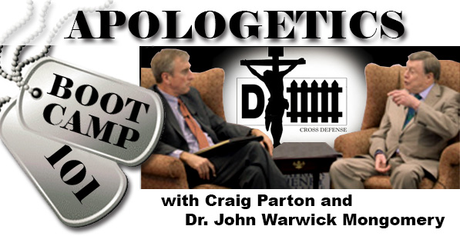
DOWNLOADABLE
BIBLE STUDY
FOR THE BROADCAST OF
DECEMBER 1, 2014

- We began this installment of Apologetics Boot Camp 101 with our continued discussion of God’s Transcendence/Immanence. Deuteronomy 29:29 was mentioned on the program as one of many representatives of this “tension” of God being “outside/other/above” the universe and His being “inside/present/with us”. What part of this Deuteronomy verse do you see as “transcendence” and as “immanence”?

- Read Hebrews 2:14-18. Is this transcendence or immanence? Or both? What words/phrases support your answer?

- Dr. Montgomery answered a question about who speaks today for Jesus. How would you answer this if asked by a skeptic? Helpful here is Luke 10:16. This is known as “the Christological principle of representation.” Who is sent by Jesus today to do this representing and how?

- 1 John 4:1 is mentioned also by Dr. Montgomery as a key passage about discerning false from true prophets. What does this passage and the following three verses (2-6) say about this?

